TRS WEB
Quality Assurance Test Report
Test Approach • Decision Tables • Test Cases • Defect Report • Additional Analysis

Application Under Test: TRS Web
trs-web.vercel.app
Prepared by: Masindi Sekhwari
Date: 24 July 2026
TRS.Web.Automation Test Suite

Table of Contents
Executive Summary 1
Test Environment 1
4.1 Test Approach 1
4.1 Test Approach Note 1
Objective 1
Test Approach 1
Scope 1
Scope Boundaries 1
4.2 Decision Tables 1
Login Decision Table (Corrected) 1
Password Registration Decision Table (Corrected) 1
Full Execution Log — Password Rules Tested With and Without a Special Character 1
4.3 Issues, Bugs & Feature Observations 1
Functional Defects 1
BUG-001 — Deleting a person on the People grid does not actually delete them 1
BUG-002 — “Edit” action on a People grid row does nothing 1
BUG-003 — “Add Person” dialog shows the wrong title (“Add Hobby”) 1
BUG-004 — Edit/Delete buttons on the Hobbies page have broken accessibility labels (“[object Object]”) 1
BUG-005 — Spelling/copy errors on the My Hobbies page (“Hobbbie”, “hobies”, “Add Hoby”) 1
BUG-006 — Password validation message is misleading and does not match the actual rules enforced 1
General Usability Observations 1
OBS-001 — Users table allows all columns to be hidden 1
OBS-002 — Logout is located under the profile menu 1
OBS-003 — Registration redirects users to the Login page after successful registration 1
OBS-004 — Validation messages could be more descriptive 1
OBS-005 — “Link Hobby” User dropdown can grow long enough to trigger a click-intercept on the last option 1
4.4 Test Cases 1
Authentication 1
TC-AUTH-001 — Register with valid details (Positive) 1
TC-AUTH-002 — Login with valid credentials (Positive) 1
TC-AUTH-003 — Login with invalid credentials (Negative) 1
TC-AUTH-004 — Logout (Positive) 1
People 1
TC-PPL-001 — Add Person with valid details (Positive) 1
TC-PPL-002 — Edit Person from the People grid (Negative — confirms BUG-002) 1
TC-PPL-003 — Delete Person from the People grid (Negative — confirms BUG-001) 1
TC-PPL-004 — Add Person with required fields left blank (Negative) 1
TC-PPL-005 — Add Person with an email that already exists (Duplicate email) (Negative) 1
TC-PPL-006 — Add Person with boundary-length values (Boundary) 1
Hobbies 1
TC-HBY-001 — Add Hobby with valid details (Positive) 1
TC-HBY-002 — Edit Hobby name and type (Positive) 1
TC-HBY-003 — Delete Hobby (Positive) 1
TC-HBY-004 — Add Hobby with a name that already exists (Duplicate hobby) (Negative) 1
TC-HBY-005 — Add Hobby with required fields left blank (Negative) 1
Dashboard 1
TC-DSH-001 — Dashboard statistics update after adding data (Positive) 1
TC-DSH-002 — Hobby Distribution chart updates (Positive) 1
Navigation 1
TC-NAV-001 — Primary navigation between tabs (Positive) 1
4.6 Additional Analysis 1
Risks 1
Risk Notes 1
Test Data Considerations 1
Accessibility Observations 1
Recommendations 1
Conclusion 1
Appendix A — Bug / Observation Template 1
Appendix B — Test Case Template 1

Right-click the table above and choose “Update Field” (or press F9) after opening in Word to populate page numbers.

Executive Summary
This report presents the findings of a quality assessment conducted against the TRS Web application (trs-web.vercel.app), covering authentication, people management, hobby management, and dashboard functionality. Testing combined risk-based manual exploratory testing with structured test case design and Selenium-based automated regression checks.
Five functional defects were identified, ranging in severity from Critical to Trivial. The most significant finding is that the People grid's delete action does not persist — selected records reappear after a page reload despite the UI indicating success — alongside a completely non-functional Edit action on the same grid. Additional defects cover a mislabelled dialog title, broken accessibility labels on the Hobbies page, and cosmetic copy errors. A further usability observation was raised regarding a dropdown interaction risk in the Link Hobby dialog.
Core workflows — registration, login, logout, adding people and hobbies, linking hobbies to users, and dashboard reporting — were verified to function correctly and were cross-checked against live, uncashed data. The recommendations in this report prioritise resolving the CRUD defects affecting data integrity, followed by usability and accessibility improvements.

Test Environment
Application Under Test | TRS Web (trs-web.vercel.app)
Environment Type | Shared, publicly accessible demo environment (not an isolated test environment)
Browser | Chrome 150.0.7871.181
Operating System | Windows 10.0.26200
Automation Framework | Selenium 4.46.0
Runtime | .NET 8.0.27
Test Types Performed | Manual exploratory testing, structured test case execution, automated Selenium regression suite

4.1 Test Approach

4.1 Test Approach Note

Objective
The objective of this assessment was to evaluate the quality and reliability of the TRS Web application by validating the functionality provided within the assessment scope. The focus was on identifying functional defects, validating business workflows, and assessing the application's usability through manual exploratory testing and automated regression tests.

Test Approach
I adopted a risk-based exploratory testing approach, focusing first on the application's critical user journeys before testing supporting functionality.
To gain an understanding of the system, I initially explored the application to identify its primary workflows and dependencies. Once the application flow was understood, I prioritised testing according to business impact.
Testing was performed in the following order:
- User Registration
- User Login
- User Logout
- People Management
- Hobby Management
- Dashboard and Charts
Authentication was prioritised because it is the entry point to all protected functionalities. Once authentication was verified, CRUD functionality and navigation were validated.
The following test design techniques were used:
- Exploratory Testing
- Positive Testing
- Negative Testing
- Boundary Value Analysis
- Equivalence Partitioning
- Error Guessing

Scope
The following functional areas were included in testing:
- User Registration
- Login
- Logout
- Dashboard
- People
- My Hobbies
- Charts

Scope Boundaries
Testing was limited to the functionality available within the supplied demo application.
The following activities were intentionally excluded in accordance with the assessment instructions:
- Performance testing
- Load testing
- Denial-of-Service testing
- Testing outside the provided application

4.2 Decision Tables

Login Decision Table
Rule | Registered User | Correct Password | Expected Result (corrected) | Verified Actual Result
1 | Yes | Yes | Login successful | Redirected to /dashboard (200 OK on credentials callback).
2 | Yes | No | Login rejected (401); remains on Sign In page. No error message is displayed to the user. | Confirmed — screenshot shows no visible message.
3 | No | Yes | Login rejected (401); remains on Sign In page. No error message is displayed to the user. | Confirmed — identical behaviour to Rule 2/4.
4 | No | No | Login rejected (401); remains on Sign In page. No error message is displayed to the user. | Confirmed — identical behaviour to Rule 2/3.
Note: Rules 3 and 4 are behaviourally indistinguishable in this system — an unregistered email always fails regardless of the password supplied, since there is no stored password to compare against. This is expected and not a defect; it is called out only because the original table implies these are two independently meaningful test conditions.

Password Sign-Up Decision Table

Rule | ≥8 Characters | Contains a Letter (either case) | Number | Special Character | Sign-Up Allowed
1 | Yes | Yes | Yes | Yes | Yes
2 | No | Yes | Yes | Yes | No
3 | Yes | No | Yes | Yes | No
4 | Yes | Yes | No | Yes | No
5 | Yes | Yes | Yes | No | No

Full Execution Log — Password Rules Tested With and Without a Special Character
Rule Tested | Password Used | Special Char? | Result | Message Shown / Outcome
Rule 1 (≥8, U, L, N) | Abcdefgh1 (9 chars) | No | Rejected | “Password must contain a combination of lowercase letters, numbers, and uppercase letters.”
Rule 1 (≥8, U, L, N) | Abcdefgh1! (10 chars) | Yes | Accepted | Redirected to Sign In.
Rule 1 boundary | Abcdef1! (exactly 8 chars) | Yes | Accepted | Confirms boundary is ≥8, not >8.
Rule 2 (<8, U, L, N) | Ab1cdef (7 chars) | No | Rejected | “Password must be at least 8 characters.”
Rule 2 (<8, U, L, N) | Ab1cde! (7 chars) | Yes | Rejected | Same length message — special character does not waive the length rule.
Rule 3 (≥8, no Upper, L, N) | abcdefgh1 (9 chars) | No | Rejected | “…combination…” message.
Rule 3 (≥8, no Upper, L, N) | abcdefgh1! (10 chars) | Yes | Accepted (unexpected) | Registered successfully with zero uppercase letters.
Rule 3 re-verification | zzzzzzzz9# (10 chars) | Yes | Accepted (unexpected) | Re-confirmed with a second password — not a fluke.
Rule 4 (≥8, Upper, no Lower, N) | ABCDEFGH1 (9 chars) | No | Rejected | “…combination…” message.
Rule 4 (≥8, Upper, no Lower, N) | ABCDEFGH1! (10 chars) | Yes | Accepted (unexpected) | Registered successfully with zero lowercase letters.
Rule 5 (≥8, U, L, no Number) | Abcdefgh (8 chars) | No | Rejected | “…combination…” message.
Rule 5 (≥8, U, L, no Number) | Abcdefgh! (9 chars) | Yes | Rejected | Number requirement is strictly enforced regardless of special character.
Extra check | 12345678! (9 chars, no letters at all) | Yes | Rejected | Confirms at least one letter (either case) is still required.
Note: The password validation message itself is misleading — it says the password “must contain a combination of lowercase letters, numbers, and uppercase letters,” but never mentions the special character it actually requires, and implies both letter cases are mandatory when only one is. This has been logged as BUG-006 in section 4.3.

4.3 Issues, Bugs & Feature Observations

Functional Defects
Each defect below follows the Bug / Observation template (ID, Title, Type, Severity, Priority, Environment, Preconditions, Steps to reproduce, Expected result, Actual result, Evidence, Notes).

BUG-001 — Deleting a person on the People grid does not actually delete them
ID | BUG-001
Title | Deleting a person on the People grid does not actually delete them
Type | Defect
Severity | Critical
Priority | High
Environment | Chrome 150.0.7871.181, Windows 10.0.26200, https://trs-web.vercel.app/people
Preconditions | Logged in as a valid user. At least one person exists on the People grid.
Steps to reproduce | 1. Navigate to the People tab.  2. Tick the checkbox on any row (e.g. a newly added person).  3. Click the “Delete” button that appears in the toolbar.  4. Reload the People page.
Expected result | The selected person is permanently removed and no longer appears in the grid, including after a page reload.
Actual result | The row's checkbox selection is cleared and the Delete button disappears, giving the impression the delete succeeded, but the person is still present in the grid after reloading the page. No backend delete actually occurs.
Evidence | See screenshot(s) below.
Notes | Reproduced consistently across multiple automated test runs (see DeletePerson_WhenConfirmed_ShouldNotAppearAfterRefresh in the automated suite). Suspected cause: the Delete button only clears client-side selection state and never calls a delete API. No workaround available from the UI.
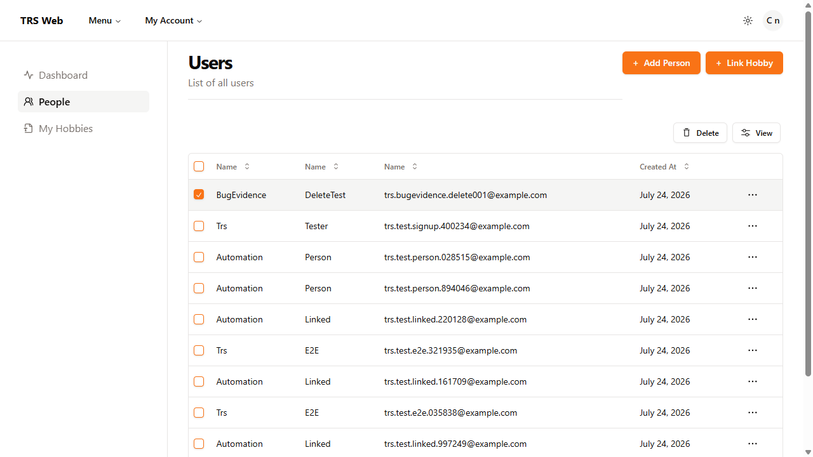
Person “BugEvidence DeleteTest” selected, Delete button visible, immediately before clicking Delete.
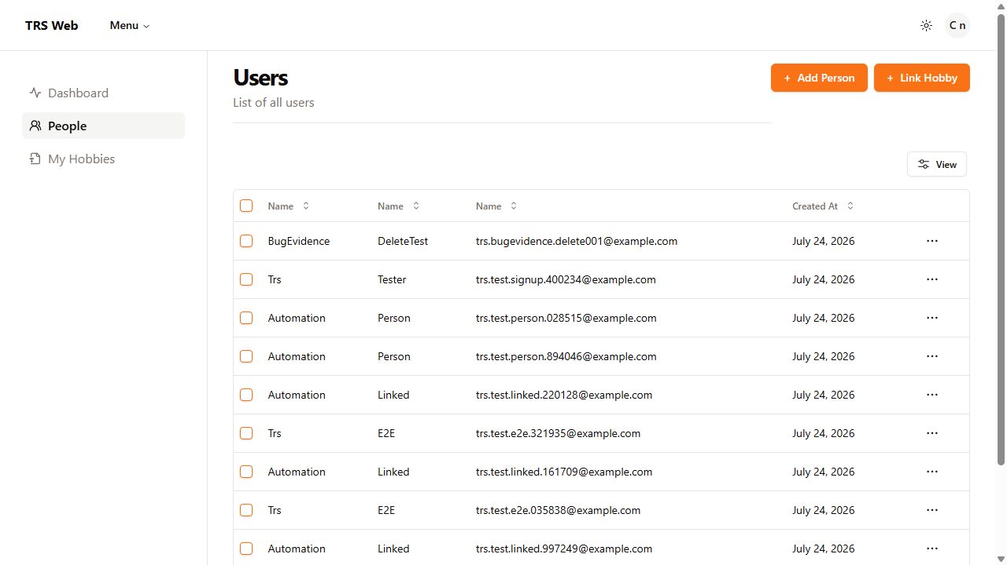
Same person still listed at the top of the grid after clicking Delete and reloading the page.

BUG-002 — “Edit” action on a People grid row does nothing
ID | BUG-002
Title | “Edit” action on a People grid row does nothing
Type | Defect
Severity | Major
Priority | High
Environment | Chrome 150.0.7871.181, Windows 10.0.26200, https://trs-web.vercel.app/people
Preconditions | Logged in as a valid user. At least one person exists on the People grid.
Steps to reproduce | 1. Navigate to the People tab.  2. Click the “⋯” (Open menu) icon on any row.  3. Click “Edit” in the dropdown menu that appears.
Expected result | An edit dialog opens, pre-filled with that person's details, allowing their name/email to be updated.
Actual result | Nothing happens. No dialog opens and no navigation occurs. Inspecting the DOM shows the “Edit” menu item is an anchor tag with an empty href, so the click has no effect.
Evidence | See screenshot(s) below.
Notes | Reproduced consistently (see EditPerson_WhenClicked_ShouldDisplayEditDialog in the automated suite). Suspected cause: the Edit menu item was never wired to open the edit dialog / navigate to an edit route.
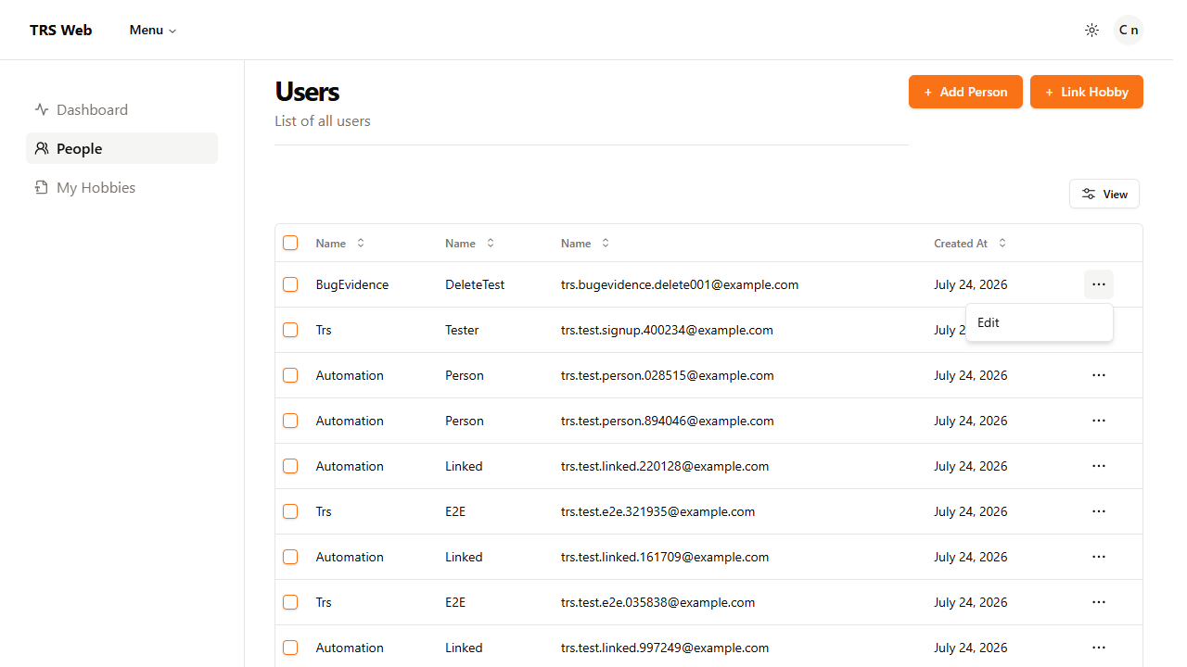
“⋯” menu open on a row, showing the “Edit” option, immediately before clicking it.
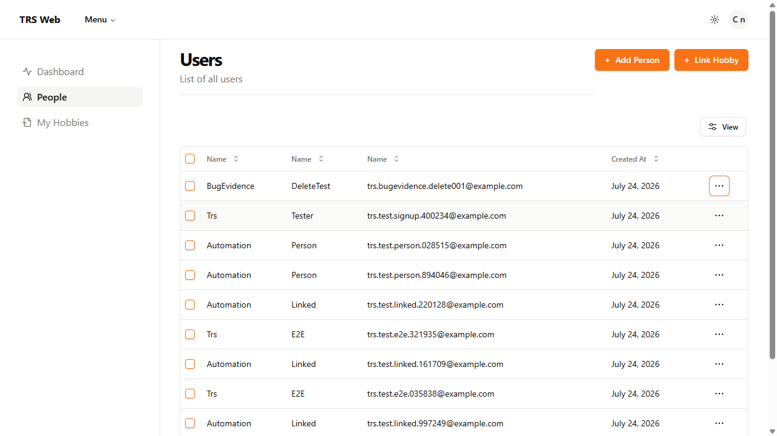
Same page state after clicking “Edit” — no dialog appeared (confirmed 0 dialog elements in the DOM).

BUG-003 — “Add Person” dialog shows the wrong title (“Add Hobby”)
ID | BUG-003
Title | “Add Person” dialog shows the wrong title (“Add Hobby”)
Type | Defect
Severity | Minor
Priority | Low
Environment | Chrome 150.0.7871.181, Windows 10.0.26200, https://trs-web.vercel.app/people
Preconditions | Logged in as a valid user, on the People tab.
Steps to reproduce | 1. Navigate to the People tab.  2. Click “+ Add Person”.
Expected result | The dialog header reads something like “Add Person”, matching the action being performed.
Actual result | The dialog header reads “Add Hobby”, even though the form fields shown are for creating a person (first name, last name, email, password).
Evidence | See screenshot(s) below.
Notes | Cosmetic/copy defect, but potentially confusing for real users. Suspected cause: a shared dialog title/component was copy-pasted from the Add Hobby flow and not updated.
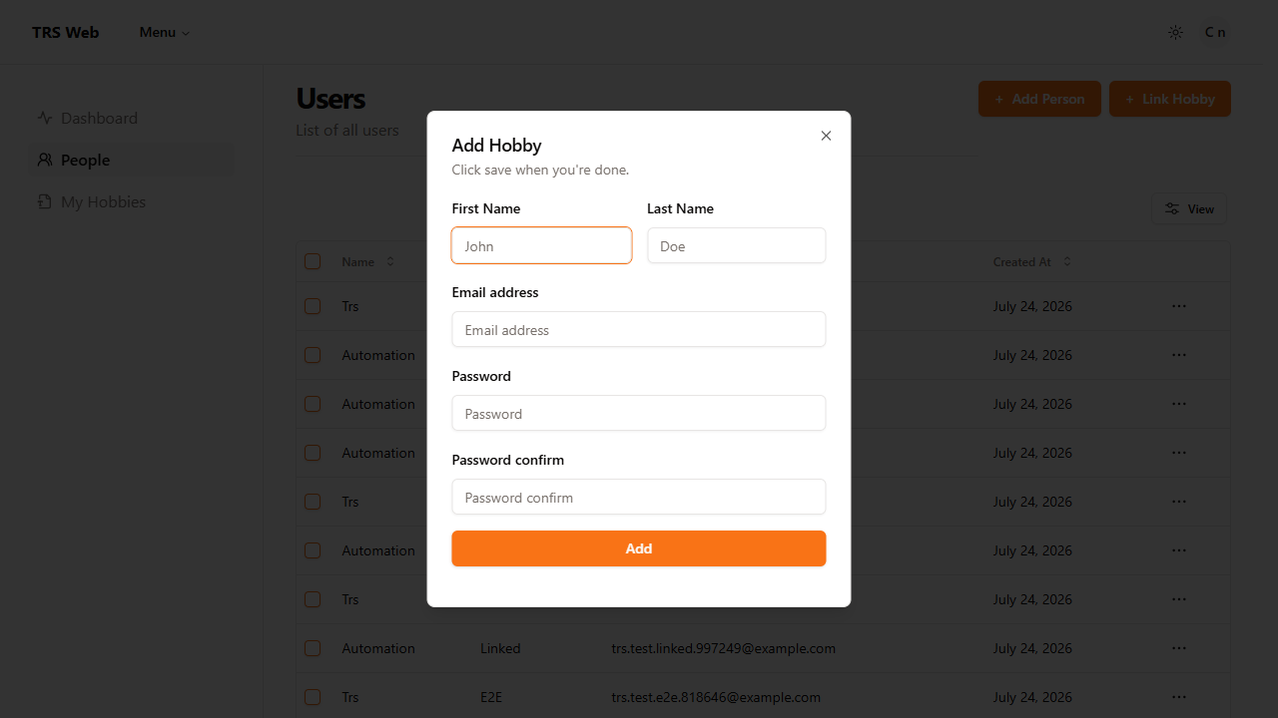
“Add Person” dialog open, header incorrectly reading “Add Hobby”.

BUG-004 — Edit/Delete buttons on the Hobbies page have broken accessibility labels (“[object Object]”)
ID | BUG-004
Title | Edit/Delete buttons on the Hobbies page have broken accessibility labels (“[object Object]”)
Type | Defect
Severity | Minor
Priority | Medium
Environment | Chrome 150.0.7871.181, Windows 10.0.26200, https://trs-web.vercel.app/hobbies
Preconditions | Logged in as a valid user, on the My Hobbies tab, with at least one hobby listed.
Steps to reproduce | 1. Navigate to the My Hobbies tab.  2. Inspect the “Edit” or “Delete” button on any hobby row (e.g. via browser DevTools or a screen reader).
Expected result | The button's aria-label describes the action and the specific hobby, e.g. “Edit Dancing” or “Delete Dancing”, so assistive technology announces something meaningful.
Actual result | The aria-label literally reads “Edit [object Object]” / “Delete [object Object]” — a JavaScript object was interpolated directly into the label string instead of a property such as the hobby's name.
Evidence | See screenshot(s) below.
Notes | Accessibility defect — screen reader users hear “[object Object]” instead of actionable context. Suspected cause: aria-label built via string interpolation of an object reference instead of a property (e.g. a hobby name).
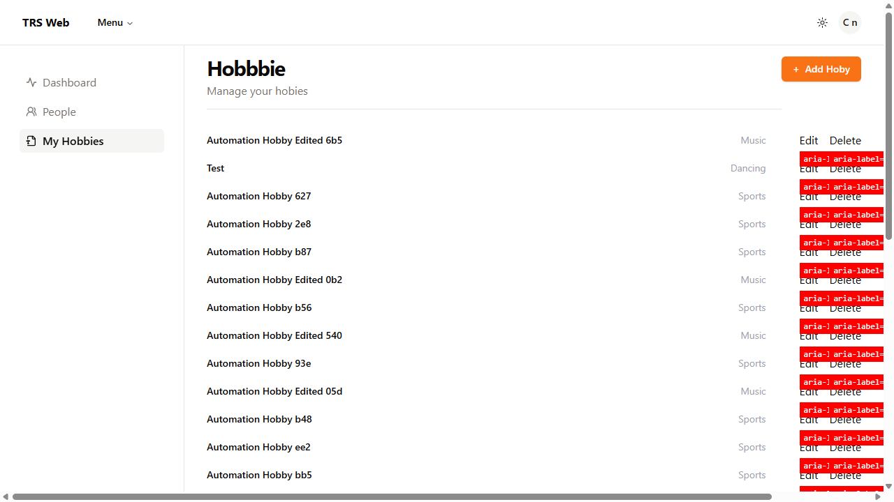
My Hobbies page with each Edit/Delete button's actual aria-label value annotated in red directly above it (62 buttons affected on this page).

BUG-005 — Spelling/copy errors on the My Hobbies page (“Hobbbie”, “hobies”, “Add Hoby”)
ID | BUG-005
Title | Spelling/copy errors on the My Hobbies page (“Hobbbie”, “hobies”, “Add Hoby”)
Type | Defect
Severity | Trivial
Priority | Low
Environment | Chrome 150.0.7871.181, Windows 10.0.26200, https://trs-web.vercel.app/hobbies
Preconditions | Logged in as a valid user.
Steps to reproduce | 1. Navigate to the My Hobbies tab.  2. Read the page heading, subtitle, and “Add” button label.
Expected result | Page reads “Hobbies”, subtitle “Manage your hobbies”, button “+ Add Hobby”.
Actual result | Page heading reads “Hobbbie”, subtitle reads “Manage your hobies”, and the add button reads “+ Add Hoby”.
Evidence | See screenshot(s) below.
Notes | Cosmetic only, no functional impact. Low effort to fix (static copy).
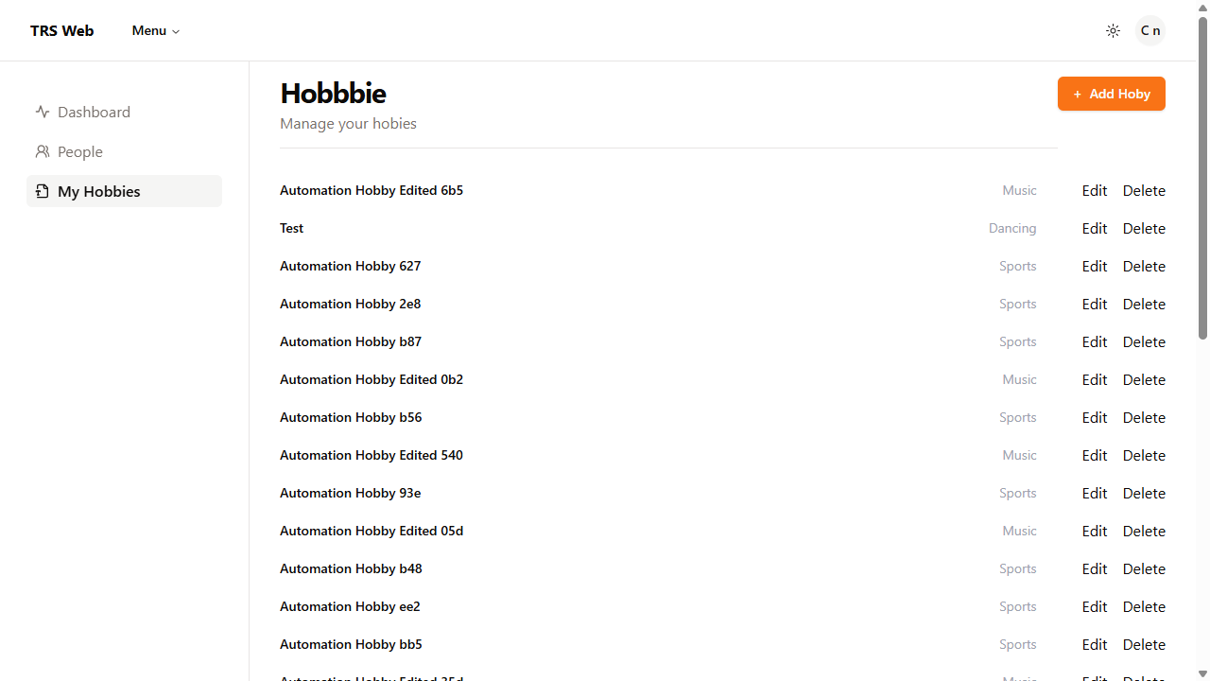
My Hobbies page header showing all three spelling errors.

BUG-006 — Password validation message is misleading and does not match the actual rules enforced
ID | BUG-006
Title | Password validation message is misleading and does not match the actual rules enforced
Type | Defect
Severity | Minor
Priority | Medium
Environment | Chrome 150.0.7871.181, Windows 10.0.26200, https://trs-web.vercel.app/auth/register
Preconditions | On the Sign-Up page.
Steps to reproduce | 1. Navigate to the Sign-Up page.  2. Enter a password that is missing a special character (e.g. “Abcdefgh1”) alongside otherwise valid detail.  3. Click Submit and read the validation message shown.  4. Separately, submit passwords missing either uppercase or lowercase letters entirely (see the Full Execution Log in section 4.2) and observe that they are accepted.
Expected result | The validation message accurately lists every rule enforced by the server, so a user can correct their input on the first attempt.
Actual result | The message reads “Password must contain a combination of lowercase letters, numbers, and uppercase letters,” but (a) never mentions the special character that is in fact required — confirmed by decision-table testing in section 4.2, and (b) implies both letter cases are mandatory when testing showed only one is (passwords with zero uppercase, or zero lowercase, letters were accepted as long as a number and special character were present).
Evidence | N/A (no screenshot captured).
Notes | Identified during re-verification of the 4.2 Password Registration decision table. Recommendation: rewrite the message to state the real rules — minimum 8 characters, at least one letter (either case), at least one number, and at least one special character.

General Usability Observations

OBS-001 — Users table allows all columns to be hidden
ID | OBS-001
Title | Users table allows all columns to be hidden
Type | Usability
Severity | Minor
Priority | Low
Environment | Chrome 150.0.7871.181, Windows 10.0.26200, https://trs-web.vercel.app/people
Preconditions | Logged in as a valid user, on the People tab.
Steps to reproduce | 1. Navigate to the People tab.  2. Click “View” (Toggle columns) in the table toolbar.  3. Toggle off every column, including Name and Email.
Expected result | At least one identifying column (e.g. Name or Email) remains visible, or a “Reset Columns” option is available to restore the defaults.
Actual result | Every column — including First Name, Last Name, Email, and Created At — can be hidden at the same time, potentially leaving the table with no identifying information, and there is no built-in way to reset to the default column set.
Evidence | See screenshot(s) below.
Notes | Recommendation: keep default columns visible or provide a “Reset Columns” option.
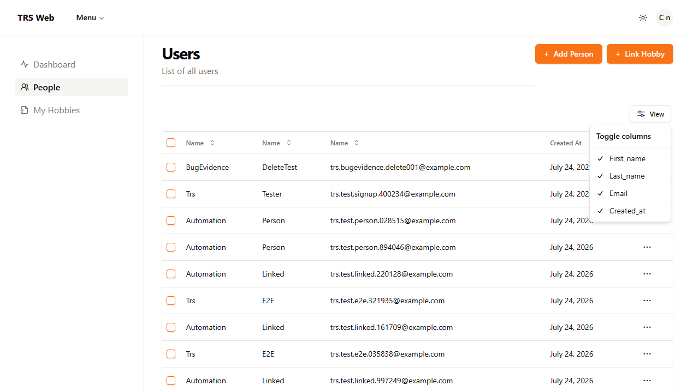
People grid — “Toggle columns” menu open, showing every column can be switched off at once.

OBS-002 — Logout is located under the profile menu ( I do not mind this but for a novice user would it take them longer to figure out ?)
ID | OBS-002
Title | Logout is located under the profile menu
Type | Usability
Severity | Minor
Priority | Low
Environment | Chrome 150.0.7871.181, Windows 10.0.26200, https://trs-web.vercel.app (any authenticated page)
Preconditions | Logged in as a valid user.
Steps to reproduce | 1. Look at the page header for a way to log out.  2. Click the avatar/profile icon in the header.  3. Observe “Log Out” nested inside the resulting dropdown menu.
Expected result | Logging out is easily discoverable, e.g. as a direct action visible in the header without needing to open a nested menu first.
Actual result | “Log Out” is only reachable by opening the avatar/profile dropdown menu — it is not visible or hinted at directly in the header.
Evidence | See screenshot(s) below.
Notes | Recommendation: consider making logout more discoverable.
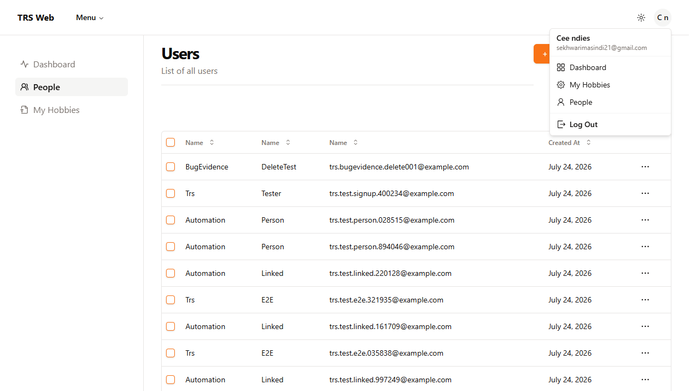
Profile/avatar menu open — “Log Out” is nested at the bottom of this menu.

OBS-003 — Registration redirects users to the Login page after successful registration
ID | OBS-003
Title | Registration redirects users to the Login page after successful registration
Type | Usability
Severity | Minor
Priority | Low
Environment | Chrome 150.0.7871.181, Windows 10.0.26200, https://trs-web.vercel.app/auth/register
Preconditions | On the Sign-Up page, with a new, unique, valid set of registration details.
Steps to reproduce | 1. Navigate to the Sign-Up page.  2. Fill in First Name, Last Name, Email, Password, and Password Confirm with valid, matching values.  3. Click Submit.
Expected result | The user is either automatically logged in or shown a clear confirmation that their account was created and what to do next.
Actual result | The user is redirected straight to the Login page with no confirmation message or any indication that their account was created.
Evidence | See screenshot(s) below.
Notes | Recommendation: consider automatically logging users in or informing them of the next step.
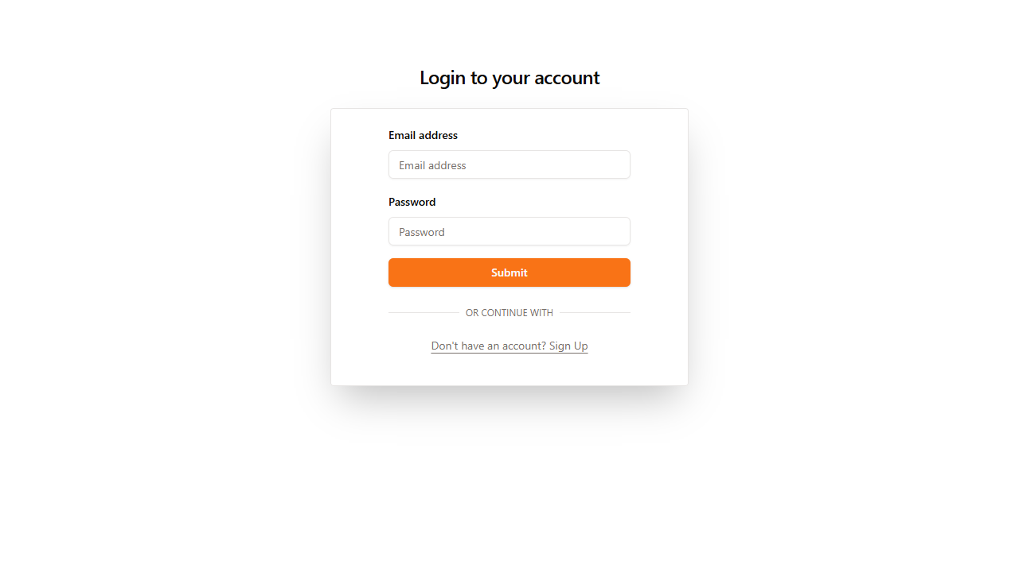
Post-sign-up state — redirected to the Login page with no confirmation message.

OBS-004 — Validation messages could be more descriptive
ID | OBS-004
Title | Validation messages could be more descriptive
Type | Usability
Severity | Minor
Priority | Low
Environment | Chrome 150.0.7871.181, Windows 10.0.26200, https://trs-web.vercel.app/auth/register
Preconditions | On the Sign-Up page.
Steps to reproduce | 1. Navigate to the Sign-Up page.  2. Leave all fields empty.  3. Click Submit.  4. Observe the validation messages shown for each field.
Expected result | Every required field shows a consistent, descriptive validation message explaining what is needed and in what format.
Actual result | First Name, Last Name, Email, and Password each show a message, but Password Confirm shows no message at all despite also being required. Separately, “Email must be a valid email” is circular and does not explain what a valid format looks like.
Evidence | See screenshot(s) below.
Notes | Recommendation: improve consistency and clarity of validation feedback.
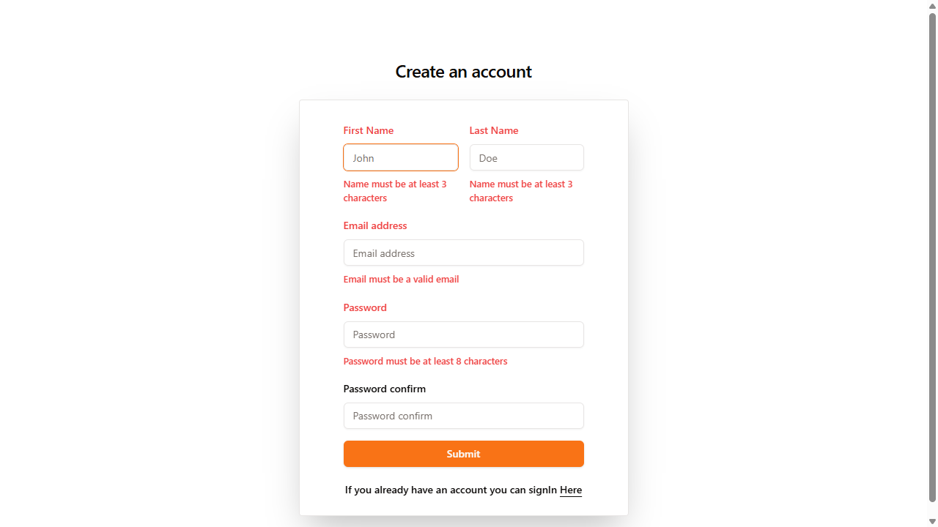
Sign Up form submitted empty — Password Confirm shows no message despite being required.

OBS-005 — “Link Hobby” User dropdown can grow long enough to trigger a click-intercept on the last option
ID | OBS-005
Title | “Link Hobby” User dropdown can grow long enough to trigger a click-intercept on the last option
Type | Observation
Severity | Minor
Priority | Low
Environment | Chrome 150.0.7871.181, Windows 10.0.26200, https://trs-web.vercel.app/people
Preconditions | The People tab's “User” select list (Link Hobby dialog) has accumulated many options.
Steps to reproduce | 1. Navigate to the People tab.  2. Click “+ Link Hobby”.  3. Open the “User” dropdown and attempt to click the very last option in the list.
Expected result | The last option in the list is reliably clickable like any other option.
Actual result | Once the list is long enough to require scrolling, the last visible option can be partially obscured by the dropdown's own scroll-down affordance icon, causing a click at that exact position to occasionally hit the icon instead of the intended option.
Evidence | N/A (no screenshot captured).
Notes | Not a functional defect in the app — the dropdown itself works correctly once scrolled properly into view. Flagged because it is a real interaction risk for any very long select list and is a side effect of test data accumulating in this shared environment. No screenshot captured; fixed at the automation level by scrolling the target option into view before clicking.

4.4 Test Cases
Each test case below follows the Test Case template (ID, Title, Area, Preconditions, Test data, Steps, Expected result, Actual result, Status). Cases marked Pass/Fail have been executed manually or via the automated regression suite; cases marked Not Executed are documented for coverage but have not yet been run.

Authentication

TC-AUTH-001 — Register with valid details (Positive)
ID | TC-AUTH-001
Title | Register with valid details (Positive)
Area | Authentication
Preconditions | On the Sign-Up page (/auth/register), not currently logged in.
Test Data | First Name: Trs, Last Name: Tester, Email: unique generated address (e.g. trs.test.signup.482913@example.com), Password / Confirm: TestPass123!
Steps | 1. Navigate to /auth/register.  2. Enter First Name, Last Name, Email, Password, and Password Confirm.  3. Click Submit.
Expected Result | Account is created and the user is redirected to the Sign In (Login) page.
Actual Result | Redirected to the Login page as expected. No confirmation message is shown indicating the account was created (see Feature Observation OBS-003).
Status | Pass

TC-AUTH-002 — Login with valid credentials (Positive)
ID | TC-AUTH-002
Title | Login with valid credentials (Positive)
Area | Authentication
Preconditions | A registered account exists. On the Login page (/auth/login).
Test Data | A known valid email/password pair for an existing account.
Steps | 1. Navigate to /auth/login.  2. Enter the valid email and password.  3. Click Submit.
Expected Result | The credentials callback returns 200 OK and the user is redirected to /dashboard.
Actual Result | Credentials callback returned 200 OK; redirected to the dashboard as expected.
Status | Pass

TC-AUTH-003 — Login with invalid credentials (Negative)
ID | TC-AUTH-003
Title | Login with invalid credentials (Negative)
Area | Authentication
Preconditions | On the Login page (/auth/login).
Test Data | Email: invalid.user@example.com, Password: IncorrectPassword123
Steps | 1. Navigate to /auth/login.  2. Enter the invalid email and password.  3. Click Submit.
Expected Result | The credentials callback returns 401 Unauthorized and the user remains on the Login page.
Actual Result | Credentials callback returned 401 Unauthorized; user remained on the Login page as expected.
Status | Pass

TC-AUTH-004 — Logout (Positive)
ID | TC-AUTH-004
Title | Logout (Positive)
Area | Authentication
Preconditions | Logged in with a valid account, on the Dashboard.
Test Data | N/A
Steps | 1. Click the avatar/profile icon in the header.  2. Click “Log Out” in the menu that opens.
Expected Result | The user is redirected back to the Login page.
Actual Result | Redirected to the Login page as expected.
Status | Pass

People

TC-PPL-001 — Add Person with valid details (Positive)
ID | TC-PPL-001
Title | Add Person with valid details (Positive)
Area | People
Preconditions | Logged in, on the People tab.
Test Data | First Name: Automation, Last Name: Person, Email: unique generated address, Password / Confirm: TestPass123!
Steps | 1. Click “+ Add Person”.  2. Enter First Name, Last Name, Email, Password, and Password Confirm.  3. Click Submit.
Expected Result | The new person appears in the People grid.
Actual Result | The new person appeared in the grid as expected. (Note: automated coverage for this scenario is currently disabled in the regression suite pending review.)
Status | Pass

TC-PPL-002 — Edit Person from the People grid (Negative — confirms BUG-002)
ID | TC-PPL-002
Title | Edit Person from the People grid (Negative — confirms BUG-002)
Area | People
Preconditions | At least one person exists in the People grid.
Test Data | Any existing person's row.
Steps | 1. Click the “⋯” (Open menu) icon on a row.  2. Click “Edit” in the dropdown menu.
Expected Result | An edit dialog opens, pre-filled with that person's details.
Actual Result | No dialog opens and no navigation occurs. See BUG-002.
Status | Fail

TC-PPL-003 — Delete Person from the People grid (Negative — confirms BUG-001)
ID | TC-PPL-003
Title | Delete Person from the People grid (Negative — confirms BUG-001)
Area | People
Preconditions | At least one person exists in the People grid.
Test Data | Any existing person's row.
Steps | 1. Tick the checkbox on a row.  2. Click “Delete” in the toolbar.  3. Reload the People page.
Expected Result | The person is permanently removed and does not reappear after reload.
Actual Result | The person still appears in the grid after reload. See BUG-001.
Status | Fail

TC-PPL-004 — Add Person with required fields left blank (Negative)
ID | TC-PPL-004
Title | Add Person with required fields left blank (Negative)
Area | People
Preconditions | On the Add Person dialog.
Test Data | All fields left blank.
Steps | 1. Open the Add Person dialog.  2. Leave First Name, Last Name, Email, Password, and Password Confirm empty.  3. Click Submit.
Expected Result | Each required field shows a clear, consistent validation message.
Actual Result | Not yet executed against this specific form. The equivalent Sign Up form (same underlying component) showed inconsistent messaging — Password Confirm shows no message despite being required (see OBS-004); this form should be checked for the same issue.
Status | Not Executed

TC-PPL-005 — Add Person with an email that already exists (Duplicate email) (Negative)
ID | TC-PPL-005
Title | Add Person with an email that already exists (Duplicate email) (Negative)
Area | People
Preconditions | A person with a known email already exists in the grid.
Test Data | An email address already present in the People grid.
Steps | 1. Open the Add Person dialog.  2. Enter the duplicate email with otherwise valid details.  3. Click Submit.
Expected Result | A clear error is shown indicating the email is already in use, and no duplicate record is created.
Actual Result | Not yet executed.
Status | Not Executed

TC-PPL-006 — Add Person with boundary-length values (Boundary)
ID | TC-PPL-006
Title | Add Person with boundary-length values (Boundary)
Area | People
Preconditions | On the Add Person dialog.
Test Data | Password of exactly 8 characters (the documented minimum, per OBS-004) and a single-character First Name / Last Name.
Steps | 1. Open the Add Person dialog.  2. Enter boundary-length values for Name and Password fields.  3. Click Submit.
Expected Result | Values at or above the minimum are accepted; values below the minimum are rejected with a clear message.
Actual Result | Not yet executed.
Status | Not Executed

Hobbies

TC-HBY-001 — Add Hobby with valid details (Positive)
ID | TC-HBY-001
Title | Add Hobby with valid details (Positive)
Area | Hobbies
Preconditions | Logged in, on the My Hobbies tab.
Test Data | Name: unique generated hobby name, Hobby Type: Sports.
Steps | 1. Click “+ Add Hoby”.  2. Enter a unique hobby name.  3. Select Hobby Type “Sports”.  4. Click Submit.
Expected Result | The hobby appears in the list with the selected type.
Actual Result | The hobby appeared in the list with the correct type as expected.
Status | Pass

TC-HBY-002 — Edit Hobby name and type (Positive)
ID | TC-HBY-002
Title | Edit Hobby name and type (Positive)
Area | Hobbies
Preconditions | At least one hobby exists.
Test Data | A new unique name and Hobby Type: Music.
Steps | 1. Click Edit on a hobby row.  2. Clear the Name field and enter the new name.  3. Change Hobby Type to “Music”.  4. Click Submit.
Expected Result | The updated name/type replace the original entry; the original name is no longer listed.
Actual Result | The hobby was updated as expected; the original name no longer appeared.
Status | Pass

TC-HBY-003 — Delete Hobby (Positive)
ID | TC-HBY-003
Title | Delete Hobby (Positive)
Area | Hobbies
Preconditions | At least one hobby exists.
Test Data | Any existing hobby.
Steps | 1. Click Delete on a hobby row.  2. Confirm the deletion.  3. Reload the My Hobbies page.
Expected Result | The hobby no longer appears after reloading.
Actual Result | The hobby was removed and did not reappear after reloading, as expected.
Status | Pass

TC-HBY-004 — Add Hobby with a name that already exists (Duplicate hobby) (Negative)
ID | TC-HBY-004
Title | Add Hobby with a name that already exists (Duplicate hobby) (Negative)
Area | Hobbies
Preconditions | A hobby with a known name already exists for this user.
Test Data | An existing hobby's exact name.
Steps | 1. Click “+ Add Hoby”.  2. Enter the same name as an existing hobby.  3. Click Submit.
Expected Result | A clear error is shown, or the duplicate is otherwise rejected.
Actual Result | Not yet executed.
Status | Not Executed

TC-HBY-005 — Add Hobby with required fields left blank (Negative)
ID | TC-HBY-005
Title | Add Hobby with required fields left blank (Negative)
Area | Hobbies
Preconditions | On the Add Hobby dialog.
Test Data | Blank name, no Hobby Type selected.
Steps | 1. Open the Add Hobby dialog.  2. Leave Name blank and do not select a Hobby Type.  3. Click Submit.
Expected Result | Validation messages are shown for both Name and Hobby Type.
Actual Result | Not yet executed.
Status | Not Executed

Dashboard

TC-DSH-001 — Dashboard statistics update after adding data (Positive)
ID | TC-DSH-001
Title | Dashboard statistics update after adding data (Positive)
Area | Dashboard
Preconditions | Logged in; Dashboard statistics recorded before the action.
Test Data | N/A — a new person and two hobbies (one own, one linked) are added as the action under test.
Steps | 1. Record Total Users and Total Hobbies on the Dashboard.  2. Add a person via the People tab.  3. Add a hobby via My Hobbies.  4. Link a hobby to the added person via People > Link Hobby.  5. Reload the Dashboard and compare the statistics.
Expected Result | The Dashboard renders well-formed, non-negative statistics reflecting recent activity. (Note: exact before/after deltas are not guaranteed — trs-web.vercel.app is a shared, live environment with other concurrent users.)
Actual Result | Dashboard rendered valid, non-negative Total Users / Total Hobbies figures. Cross-checked against the People grid's real pagination count and the totals matched exactly, confirming the statistics are live rather than cached.
Status | Pass

TC-DSH-002 — Hobby Distribution chart updates (Positive)
ID | TC-DSH-002
Title | Hobby Distribution chart updates (Positive)
Area | Dashboard
Preconditions | Logged in, on the Dashboard.
Test Data | N/A
Steps | 1. Note the current Hobby Distribution chart segments and percentages.  2. Add a hobby of a specific type.  3. Reload the Dashboard.  4. Compare the chart to the earlier state.
Expected Result | The chart reflects the additional hobby (segment count/percentage updates accordingly).
Actual Result | Not yet executed via a dedicated automated assertion on the chart itself — Dashboard totals were verified (TC-DSH-001), but individual pie-chart segment values were not asserted programmatically.
Status | Not Executed

Navigation

TC-NAV-001 — Primary navigation between tabs (Positive)
ID | TC-NAV-001
Title | Primary navigation between tabs (Positive)
Area | Navigation
Preconditions | Logged in.
Test Data | N/A
Steps | 1. From the Dashboard, click “People”.  2. Click “My Hobbies”.  3. Click “Dashboard”.
Expected Result | Each click navigates to the corresponding page without error.
Actual Result | All navigations completed successfully; exercised implicitly by every test in the automated regression suite (each page object navigates directly via URL and every run confirms the destination page loads).
Status | Pass

4.6 Additional Analysis

Risks
The following areas present the greatest risk to application quality:
- Authentication failures preventing access to secured functionality.
- CRUD operations failing to persist or remove data correctly.
- Incorrect dashboard statistics leading to inaccurate reporting.
- Poor validation allowing invalid or inconsistent data to be stored.

Risk Notes
- Transient UI flakiness: a few ElementClickInterceptedException errors surfaced (a toast overlapping a button, a scroll-affordance overlapping a dropdown option) — timing-related, not deterministic bugs, but a real source of CI flakiness if not waited-for/retried explicitly. The instances encountered were fixed at the automation level.

Test Data Considerations
- Test data is centralised in a TestDataFactory (passwords, invalid credentials, hobby types, name pairs, email-label prefixes) rather than duplicated per test — this reduces typo risk and keeps test intent explicit.
- Uniqueness comes from short GUID-derived suffixes (email: 6-digit numeric; names: 3-character), not real cleanup — since the People-delete defect (BUG-001) means deletions don't persist, and most Add/Edit tests don't remove their own artifacts, the shared account accumulates test data indefinitely. This is a real, growing side effect of the current approach rather than a cosmetic concern — it is part of what caused the Link Hobby dropdown to grow long enough to trigger the scroll-affordance click issue (OBS-005).
- There is no ephemeral/provisioned test-account strategy — everything relies on one long-lived real account, which ties test stability to that account's ongoing state on an external system outside the tester's control.

Accessibility Observations
- The aria-label=“Edit [object Object]” / “Delete [object Object]” defect (BUG-004) is a genuine accessibility issue, not just cosmetic — a screen-reader user hears meaningless text instead of, for example, “Edit Dancing.”
- The dead “Edit” link (an anchor with an empty href, BUG-002) is also a semantic-HTML/ARIA concern independent of its functional failure — an element with no real destination that acts like a button is not idiomatic markup and can confuse assistive technology.

Recommendations
Based on the findings, I recommend the following improvements:
- Resolve functional defects affecting CRUD operations, particularly delete functionality.
- Improve validation messages to provide clearer feedback.
- Prevent users from hiding all table columns or provide a quick reset option.
- Ensure dialog titles accurately reflect the operation being performed.
- Continue expanding the automated regression suite to cover newly implemented functionality.

Conclusion
Manual exploratory testing, structured test case design, and Selenium-based automation were used together to validate the application's behaviour and uncover these findings, with particular care taken to distinguish genuine defects from artefacts of the shared, live test environment (see Risk Notes). The identified findings and recommendations provide a concrete, prioritised basis for improving both the reliability of CRUD operations and the overall usability of TRS Web ahead of future releases.

Appendix A — Bug / Observation Template
Used consistently in section 4.3.
Field | Description
ID | Unique identifier (e.g. BUG-001).
Title | Short, specific summary of the problem.
Type | Defect / usability / suggestion / question.
Severity | Impact on the system if it occurs (e.g. Critical / Major / Minor / Trivial).
Priority | How urgently it should be fixed (e.g. High / Medium / Low).
Environment | Browser, OS, device, and any relevant conditions.
Preconditions | State the system must be in before the steps.
Steps to reproduce | Numbered, so anyone can follow them exactly.
Expected result | What should happen.
Actual result | What actually happened.
Evidence | Screenshot, recording, console/network detail, or reference.
Notes | Frequency, workaround, suspected cause, related items.

Appendix B — Test Case Template
Used consistently in section 4.4.
Field | Description
ID | Unique identifier (e.g. TC-LOGIN-003).
Title | What the case verifies.
Area | e.g. Authentication, People, Hobbies, Dashboard, Navigation.
Type | Positive / negative / boundary (reflected inline in the Title).
Priority | High / Medium / Low.
Preconditions | Required state and any setup.
Test Data | Specific inputs used.
Steps | Numbered actions to perform.
Expected Result | The outcome that means the test passes.
Actual Result | What was actually observed when the case was executed.
Status | Pass / Fail / Not Executed.

